LEETCODE QUESTIONS

4b) 876. Middle of Linked List
Given the head of a singly linked list, return the middle node of the linked list.If there are two middle nodes, return the second middle node.
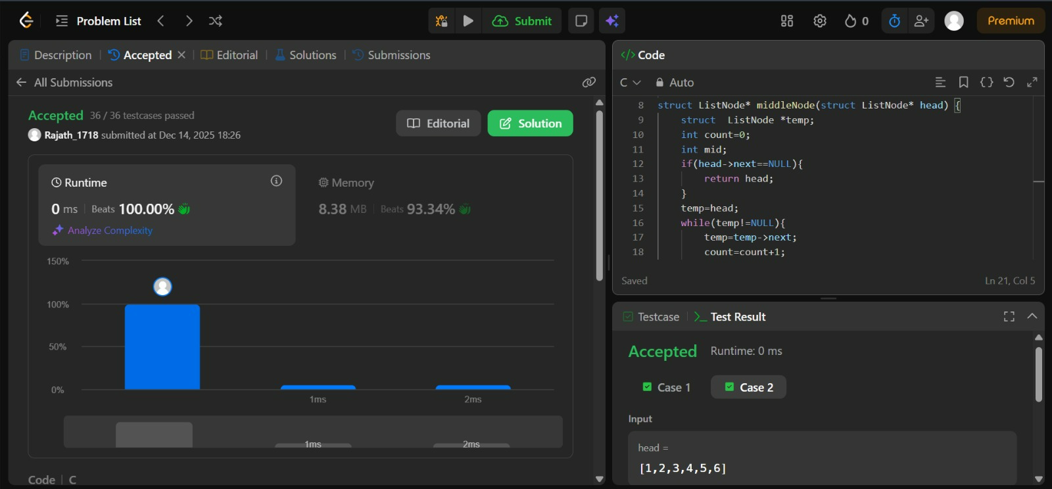

5b) 203.Remove Linked List elements
Given the head of a linked list and an integer val, remove all the nodes of the linked list that has Node.val == val, and return the new head.
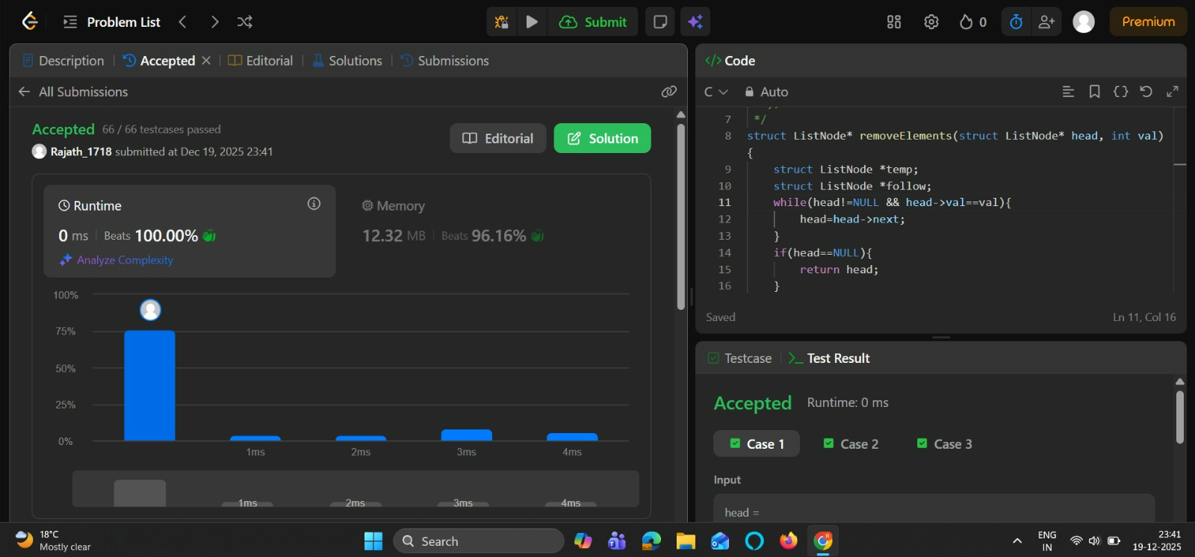

7b) 141. Linked List Cycle
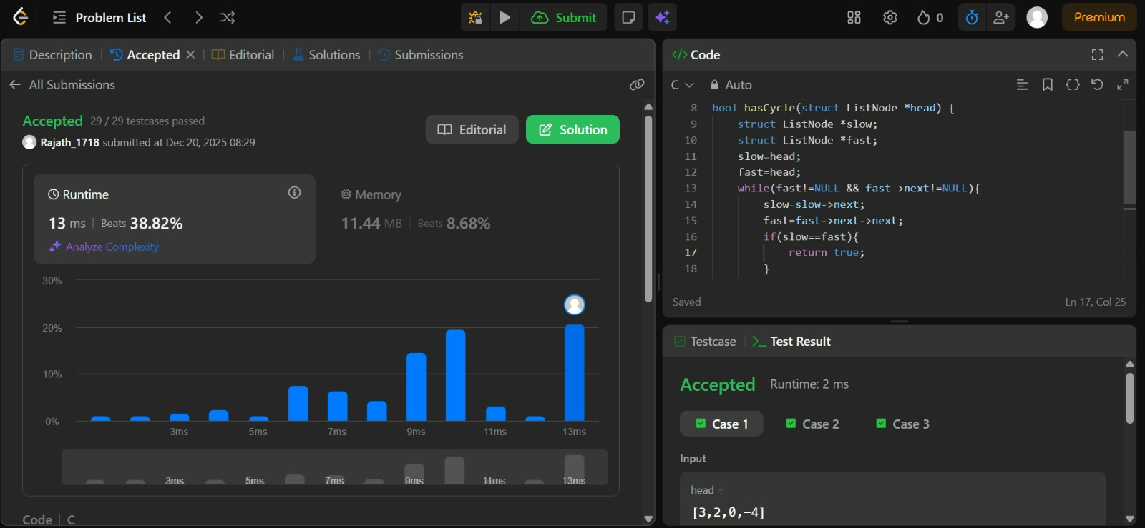

8b) 617.Merge two binary trees
